COMP 2000 Web Development Course
Assignment 5
Use of Input Elements in HTML Document

This assignment is an extension of last Assignment. In the Assignment, you will develop a contact page with use of input elements.

1. Open the folder you saved in Assignment 4.

2. Open Notepad and create a new html page contact.html and save it in the folder.
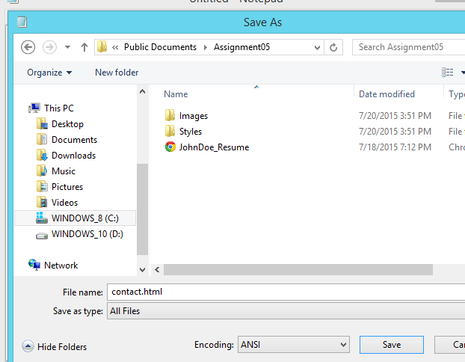

3. Create a new document using Notepad and save it as contact.css and save it in Styles folder.

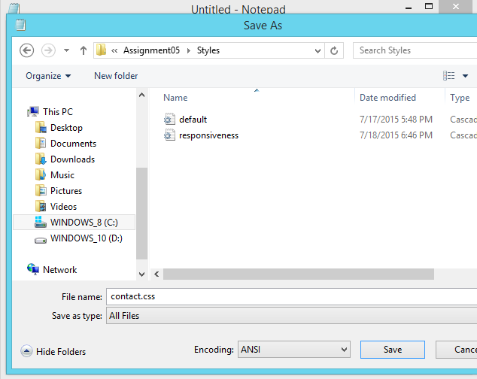

4. Contact Page should have following content:
4.1: Name field. It should be a textbox.
4.2: Email field. It should be a textbox.
4.3: Phone Number field. It should be a textbook.
4.4: Street field. It should be a textarea.
4.5: City field. It should be a textbox.
4.6: State field. It should be a dropdown field containing all the states information.
4.7: Country field. It should be a radio button. It should be by default selected.
4.8: Message field. It should be a textarea.
4.9: Submit button.
4.10: Reset button.

5. All the fields should have a description followed by respective input elements.
Ex: <p>Name: </p> <input type=“text” id=“txtName”/>

6. All the descriptions should be on the left side of the input elements.

7. All the descriptions and input elements should be perfectly aligned.

8. The width and height of all the textboxes, textareas, dropdown, radio buttons should be same.
Define borders, font, text, color properties for all the textboxes, textareas, dropdown, radio buttons
Note: All textboxes, textareas, dropdown, radio buttons should have similar style properties.

9. All the description fields should have similar style properties.

10. Submit button and Reset button should be left aligned.

11. The width and height of all the buttons should be same. Define borders, font, text, color properties for all the buttons. Note: All buttons should have similar style properties.

12. Contact page should be perfectly aligned for different screen sizes. Note: All the styles should be defined in contact.css file.
Sample result:
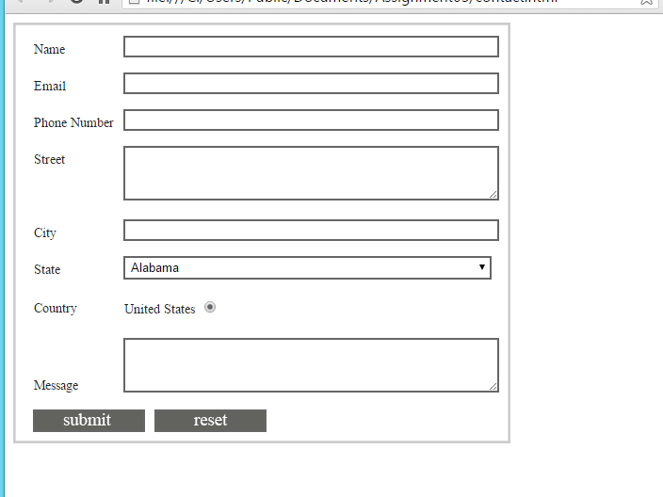
13. Save the files in the folder.
14. Save the folder, and zip the folder and submit it on canvas.

